# **Online Grocery App**

**A PROJECT REPORT**

**Submitted By**

**Vishek Tyagi**

**2200290140183**

**Submitted in partial fulfilment of the Requirements for the Degree of**

# **MASTER OF COMPUTER APPLICATIONS**

**Under the Supervision of**

**Dr. Akash Rajak**

**Professor**



**Submitted to**

**Department Of Computer Applications**

**KIET Group of Institutions, Ghaziabad Uttar Pradesh-201206**

**(May, 2024)**

## **CERTIFICATE**

Certified that **Vishek Tyagi, 2200290140183** has carried out the project work having “**Online Grocery App**” for Master of Computer Applications from Dr. A.P.J. Abdul Kalam Technical University (AKTU**)** (formerly UPTU), Technical University, Lucknow under my supervision. The project report embodies original work, and studies are carried out by the student himself / herself and the contents of the project report do not form the basis for the award of any other degree to the candidate or to anybody else from this or any other University/Institution.

**Date:**

**Vishek Tyagi (2200290140183)**

This is to certify that the above statement made by the candidate is correct to the best of my knowledge.

Dr Akash Rajak Dr. Arun Kumar Tripathi

Professor Professor & Head

Department of Computer Applications Department of Computer Applications

**KIET Group of Institutions, Ghaziabad KIET Group of Institutions, Ghaziabad**

ONLINE GROCERY APP

## **VISHEK TYAGI**

## **ABSTRACT**

The rapid advancement of digital technology and the increasing demand for convenience have significantly transformed the retail landscape, particularly in the grocery sector. This project report presents the development and enhancement of an innovative online grocery store app designed to meet the evolving needs of consumers. The app aims to provide a seamless, personalized, and user-friendly shopping experience while ensuring robust security and operational efficiency.

Our approach includes the implementation of advanced analytics to gain deeper insights into user behavior and preferences, enabling predictive modeling for inventory management and personalized recommendations. The app features real-time price monitoring to maintain competitive pricing, personalized alerts and notifications to enhance user engagement, and social features to foster community interaction and user-generated content. Additionally, we have incorporated extensive user customization options and educational resources to empower users with knowledge about nutrition and cooking.

The implementation strategy focuses on real-time price monitoring, improved search functionality, and robust user authentication. Real-time price monitoring ensures competitive pricing and accurate inventory updates, while enhanced search functionality provides users with quick and relevant search results through sophisticated algorithms and natural language processing. Our robust user authentication system ensures the security and privacy of user data through multi-factor authentication and secure session management.

A comprehensive testing strategy, including functional, performance, security, usability, and regression testing, ensures that the app is reliable, secure, and user-friendly. Continuous feedback and iterative improvements are integral to our approach, allowing us to refine features and maintain high standards of quality and user satisfaction.

In conclusion, the online grocery store app is designed to address current market demands and position itself for future growth and innovation. By leveraging advanced technology and focusing on user needs, the app provides an exceptional online grocery shopping experience, setting a new standard in the digital retail space.

## **ACKNOWLEDGEMENTS**

Success in life is never attained single handedly. My deepest gratitude goes to my thesis supervisor, **Dr. Akash Rajak** for his guidance, help and encouragement throughout my research work. Their enlightening ideas, comments, and suggestions.

Words are not enough to express my gratitude to **Dr. Arun Kumar Tripathi**, Professor and Head, Department of Computer Applications, for his insightful comments and administrative help at various occasions.

Fortunately, I have many understanding friends, who have helped me a lot on many critical conditions.

Finally, my sincere thanks go to my family members and all those who have directly and indirectly provided me moral support and other kind of help. Without their support, completion of this work would not have been possible in time. They keep my life filled with enjoyment and happiness.

**Vishek Tyagi**

**LIST OF CONTENTS**

1. Introduction 01
   1. Purpose 01
   2. Scope 01
   3. Overview 01
   4. Goals Of proposed System 01
   5. Background 02
   6. Project Requirements 02
   7. Technology Used 02
2. Feasible Study 03-06
   1. Technical Feasibility 03
   2. Economical Feasibility 04
   3. Operational Feasibility 05
   4. Schedule Feasibility 06
3. Architectural Design 07-10
   1. ER diagram 07
   2. Data flow diagram 08
   3. Use Case Diagram 09
4. System Design 11-13
   1. Architecture 11
   2. Database Structure 12
   3. Component Interactions 13
5. Future Enhancements 14-17
   1. [Advanced Analytics ……………………………………………………………..14](#_TOC_250002)
   2. Personalized Alerts and Notifications ……………………………………………..15
   3. Social Features and Community Engagement ……………………………………..16
   4. Enhanced User Customization Options ……………………………………………..17
   5. Educational Resources and Learning Tools ……………………………………..17
6. Implementation 18-21
   1. [Real-Time Price Monitoring ------------------------------------------------------------18](#_TOC_250002)
   2. Search Functionality ---------------------------------------------------------------------19
   3. User Authentication ---------------------------------------------------------------------21
7. Testing ………………………………………………………………………………22-23
8. Snapshot ……………………………………………………………………….24-26
9. Conclusion ………………………………………………………………………….27
10. References ………………………………………………………………………….28

**CHAPTER 1**

### **INTRODUCTION**

#### **1.1 Purpose**

The purpose of this project is to develop an online grocery store using the MERN stack (MongoDB, Express.js, React, Node.js). This project aims to provide a comprehensive solution for users to purchase groceries online, ensuring convenience, efficiency, and a seamless shopping experience. The system is designed to cater to the needs of modern consumers who prefer online shopping over traditional brick-and-mortar stores. By leveraging the capabilities of the MERN stack, this project aims to deliver a robust and scalable platform that can handle high volumes of transactions and provide a user-friendly interface.

The online grocery store aims to bridge the gap between grocery shoppers and suppliers by offering a digital platform where users can browse, select, and purchase groceries from the comfort of their homes. This system is particularly relevant in the current context, where the demand for online shopping solutions has surged due to various factors, including the global pandemic and the growing preference for digital services.

The project also aims to streamline the grocery shopping process by incorporating features such as real-time price monitoring, advanced search functionality, and user authentication. By automating these processes, the system reduces the time and effort required for grocery shopping, making it a more efficient and enjoyable experience for users.

#### **1.2 Scope**

The scope of this project encompasses the development, implementation, and testing of an online grocery store using the MERN stack. The project will cover the following aspects:

**User Interface (UI) Design**: Creating a user-friendly interface that allows users to easily navigate through the website, search for products, view product details, and make purchases.

**Backend Development**: Implementing a robust backend system using Node.js and Express.js to handle user requests, manage the database, and ensure secure transactions.

**Database Management**: Utilizing MongoDB to store and manage product information, user data, order details, and other relevant data.

**Real-Time Price Monitoring**: Incorporating features to monitor and update product prices in real-time to provide users with the latest pricing information.

**User Authentication and Authorization**: Implementing secure user authentication and authorization mechanisms to protect user data and ensure only authorized users can access certain features.

**Search Functionality**: Developing advanced search capabilities to allow users to quickly find products based on various criteria such as name, category, price range, etc.

**Order Processing**: Implementing a system to manage the entire order processing workflow, from adding products to the cart to making payments and tracking order status.

**Testing and Validation**: Conducting thorough testing to ensure the system is reliable, secure, and performs well under different conditions.

#### **1.3 Overview**

The online grocery store is a web-based application designed to facilitate the purchase of groceries online. The system is built using the MERN stack, which provides a powerful and flexible framework for developing modern web applications. The main components of the system include:

**Frontend**: Developed using React.js, the frontend provides a dynamic and responsive user interface that enhances the user experience.

**Backend**: The backend is built using Node.js and Express.js, providing a scalable and efficient server-side framework for handling user requests and managing the application logic.

**Database**: MongoDB is used as the database management system, offering a NoSQL solution that is well-suited for handling large volumes of data and providing fast access to information.

**User Authentication**: The system includes secure user authentication mechanisms to protect user data and ensure only authorized users can access certain features.

**Search and Filter**: Advanced search and filter functionalities allow users to quickly find the products they are looking for.

**Real-Time Price Updates**: The system monitors product prices in real-time and updates them accordingly to provide users with the latest pricing information.

**Order Management**: The order management system handles the entire workflow from product selection to payment processing and order tracking.

#### **1.4 Goals of Proposed System**

The primary goals of the proposed online grocery store system are:

**Enhance User Convenience**: Provide a platform where users can easily browse, search, and purchase groceries online, reducing the time and effort required for traditional grocery shopping.

**Improve Efficiency**: Streamline the grocery shopping process by automating various tasks such as price monitoring, order processing, and inventory management.

**Ensure Security**: Implement robust security measures to protect user data and ensure secure transactions.

**Scalability**: Develop a system that can handle a large number of users and transactions, ensuring it can grow with the business.

**Real-Time Updates**: Provide real-time updates on product prices and availability to keep users informed and enhance their shopping experience.

**User-Friendly Interface**: Design an intuitive and responsive user interface that makes it easy for users to navigate the website and find the products they need.

**Comprehensive Search Functionality**: Implement advanced search capabilities to allow users to quickly find products based on various criteria.

**Order Tracking**: Provide users with the ability to track their orders from placement to delivery, enhancing transparency and customer satisfaction.

#### **1.5 Background**

The idea for the online grocery store project stemmed from the increasing demand for convenient and efficient online shopping solutions. With the rise of digital technology and the growing preference for online services, consumers are looking for ways to simplify their grocery shopping experience. Traditional grocery shopping can be time-consuming and cumbersome, and there is a need for a system that allows users to purchase groceries from the comfort of their homes.

Market research indicated a significant opportunity for an online grocery store, particularly in light of the global pandemic, which has accelerated the shift towards online shopping. Existing solutions in the market provided valuable insights into the features and functionalities that users find most beneficial, such as real-time price updates, advanced search capabilities, and secure payment processing.

The development of the online grocery store using the MERN stack offers several advantages. The MERN stack provides a comprehensive and cohesive framework for building modern web applications, allowing for seamless integration between the frontend and backend components. MongoDB's NoSQL database is well-suited for handling the dynamic nature of product data, while Express.js and Node.js provide a powerful server-side framework. React.js offers a responsive and interactive user interface, enhancing the overall user experience.

#### **1.6 Project Requirements**

The project requirements for the online grocery store include both functional and non-functional requirements:

**Functional Requirements:**

User Registration and Login: Users must be able to register and log in to the system securely.

Product Browsing: Users should be able to browse a catalog of grocery items, view details, and select items for purchase.

Search Functionality: Users should be able to search for products based on various criteria such as name, category, and price range.

Shopping Cart: Users should be able to add products to a shopping cart, update quantities, and remove items.

Order Processing: The system should handle order placement, payment processing, and provide order confirmation.

Order Tracking: Users should be able to track the status of their orders from placement to delivery.

Real-Time Price Monitoring: The system should update product prices in real-time based on market fluctuations.

User Profile Management: Users should be able to manage their profiles, view order history, and update personal information.

**Non-Functional Requirements:**

Performance: The system should be able to handle a large number of concurrent users and transactions efficiently.

Security: The system must implement robust security measures to protect user data and ensure secure transactions.

Scalability: The system should be designed to scale easily to accommodate growing user demand.

Usability: The user interface should be intuitive and easy to navigate, providing a positive user experience.

Reliability: The system should be reliable and available, minimizing downtime and ensuring continuous operation.

Word Count: 500 words

#### **1.7 Technology Used**

The online grocery store is built using the MERN stack, which includes the following technologies:

**MongoDB**: A NoSQL database that provides a flexible and scalable solution for storing product information, user data, and order details.

**Express.js**: A web application framework for Node.js that provides a robust set of features for building web and mobile applications.

**React.js**: A JavaScript library for building user interfaces, allowing for the creation of dynamic and responsive web applications.

**Node.js**: A JavaScript runtime environment that enables the development of server-side applications using JavaScript.

These technologies were chosen for their ability to provide a cohesive and efficient framework for developing modern web applications. MongoDB's document-oriented structure is ideal for handling the dynamic nature of product data. Express.js and Node.js provide a powerful server-side framework that facilitates the development of scalable and efficient backend systems. React.js offers a flexible and interactive frontend solution, enhancing the user experience.

**CHAPTER 2**

## **FEASIBILITY STUDY**

### **2.1 Economical Feasibility**

Economical feasibility evaluates the cost-effectiveness of the project, determining whether the financial benefits outweigh the costs. The development of the online grocery store involves various initial and ongoing costs, but it also presents significant revenue potential and cost-saving opportunities. Here are the key points highlighting the economical feasibility:

**2.2 Initial Development Costs**:

Software and Tools: The use of open-source technologies like the MERN stack (MongoDB, Express.js, React, Node.js) eliminates the need for costly software licenses. Development tools such as Visual Studio Code, Git, and GitHub are also available for free.

Infrastructure: Initial costs include setting up cloud hosting and deployment services. While platforms like Heroku offer free tiers for small-scale development, scaling up may involve costs based on usage. AWS provides pay-as-you-go pricing, which can be managed efficiently based on the project's needs.

Development Team: Hiring skilled developers and designers is a significant cost. The team includes frontend and backend developers, UI/UX designers, and project managers. Salaries and contractor fees constitute a substantial portion of the budget.

**2.3 Operational Costs**:

Hosting and Maintenance: Ongoing costs for hosting, server maintenance, and cloud storage. These costs are manageable with scalable solutions like AWS and Heroku, which allow adjusting resources based on demand.

Security and Compliance: Costs associated with implementing and maintaining security measures, such as SSL certificates, regular security audits, and compliance with data protection regulations (e.g., GDPR).

Marketing and Customer Acquisition: Budget allocation for digital marketing strategies, including search engine optimization (SEO), pay-per-click (PPC) advertising, social media marketing, and content marketing. Customer acquisition costs will be balanced by strategies to retain existing customers.

**2.4 Revenue Generation**:

Sales Revenue: The primary source of revenue is the sale of groceries through the platform. By offering competitive pricing, a wide range of products, and a convenient shopping experience, the platform aims to attract a large customer base.

Subscription Models: Introducing premium membership options with benefits such as free delivery, early access to sales, and exclusive discounts. This can provide a steady revenue stream.

Advertising and Partnerships: Collaborating with brands and suppliers to offer advertising space on the platform. Sponsored products and featured listings can generate additional income.

Affiliate Programs: Partnering with other e-commerce platforms or services to offer bundled deals and earning commissions on referrals.

**2.5 Cost Savings**:

Reduced Overhead: Unlike physical stores, an online platform significantly reduces costs associated with rent, utilities, and in-store staff.

Automated Processes: Automation of various processes such as inventory management, order processing, and customer service can reduce operational costs and improve efficiency.

Bulk Purchasing: The ability to manage inventory centrally allows for bulk purchasing from suppliers at discounted rates, leading to cost savings.

**2.6 Market Demand and Growth Potential**:

Growing Market: The demand for online grocery shopping is on the rise, driven by convenience and the increasing adoption of digital services. Market research indicates a significant growth potential in this sector.

Pandemic Influence: The global pandemic has accelerated the shift towards online shopping, including groceries. This trend is likely to continue, providing a favorable market environment for the platform.

Customer Retention: Implementing loyalty programs, personalized recommendations, and excellent customer service can increase customer retention rates, leading to sustained revenue growth.

**2.7 Risk Management**:

Financial Risks: The project involves financial risks such as initial investment and ongoing operational costs. These risks can be mitigated by careful budget management, phased development, and scaling based on demand.

Market Competition: The online grocery market is competitive. The platform must differentiate itself through unique features, superior user experience, and effective marketing strategies.

Economic Uncertainty: Economic fluctuations can impact consumer spending. Diversifying revenue streams and maintaining flexibility in operations can help manage this risk.

**2.8 Return on Investment (ROI)**:

Break-Even Analysis: Estimating the break-even point where the revenue generated covers the initial and ongoing costs. This involves projecting sales volumes, pricing strategies, and cost management.

Long-Term Profitability: Analyzing long-term profitability by considering factors such as market growth, customer base expansion, and operational efficiencies. The goal is to achieve sustainable revenue that exceeds costs, providing a positive ROI.

In conclusion, the economical feasibility of the online grocery store project is supported by the growing market demand, potential for significant revenue generation, and various cost-saving opportunities. By carefully managing initial investments, operational costs, and leveraging multiple revenue streams, the project is poised to achieve financial success and provide a favorable return on investment.

### **2.9 Operational Feasibility**

Operational feasibility examines whether the project can be implemented within the current operational framework and if it will function as intended. Here are the key points highlighting the operational feasibility:

**Integration with Existing Systems**:

Inventory Management: The online grocery store integrates with existing inventory management systems to ensure real-time stock updates and efficient inventory tracking.

Order Processing: The system automates the order processing workflow, from product selection to payment and delivery. This reduces manual intervention and minimizes errors.

Customer Service: The platform includes tools for managing customer inquiries and support tickets, ensuring timely and effective customer service.

**User-Friendly Interface**:

Intuitive Design: The user interface is designed to be intuitive and easy to navigate, ensuring a positive user experience. This includes clear menus, search functionality, and straightforward checkout processes.

**Accessibility:** The platform is developed with accessibility in mind, ensuring it is usable by people with disabilities. This includes features like screen reader support and keyboard navigation.

**2.10 Training and Support**:

Training Programs: Comprehensive training programs are provided for staff to ensure they are proficient in using the system. This includes training on inventory management, order processing, and customer service tools.

Documentation: Detailed user manuals and documentation are available to guide users through various functionalities and troubleshooting steps.

**Scalability**:

Modular Architecture: The system is designed with a modular architecture, allowing for easy addition of new features and functionalities as the business grows.

Cloud Infrastructure: Utilizing cloud infrastructure like AWS ensures that the platform can scale up or down based on demand, providing flexibility and reliability.

**Automation of Processes**:

Order Fulfillment: Automation of order fulfillment processes, including picking, packing, and shipping, reduces operational costs and improves efficiency.

Inventory Replenishment: Automated inventory replenishment systems ensure that stock levels are maintained, reducing the risk of stockouts and overstocking.

**Performance and Reliability**:

Load Balancing: The use of load balancing ensures that the system can handle high volumes of traffic without compromising performance.

Redundancy and Backup: Implementing redundancy and backup solutions ensures that data is protected and the system remains operational in case of failures.

**Security Measures**:

Data Protection: Robust security measures are in place to protect user data, including encryption, secure access controls, and regular security audits.

Fraud Prevention: Systems for detecting and preventing fraudulent activities, such as unusual order patterns or payment anomalies, are implemented to safeguard the platform.

In conclusion, the operational feasibility of the online grocery store project is supported by the seamless integration with existing systems, user-friendly interface, comprehensive training and support, scalability, automation of processes, and robust performance and security measures. These factors ensure that the project can be implemented effectively within the current operational framework and will function as intended.

### **2.11 Schedule Feasibility**

Schedule feasibility assesses whether the project can be completed within the desired timeframe. It involves creating a detailed project plan with milestones and deliverables to ensure timely completion. Here are the key points highlighting the schedule feasibility:

**Project Timeline**:

**Requirements Gathering**: The initial phase involves collecting and documenting all the functional and non-functional requirements. This phase is expected to take two weeks.

**Design Phase**: This phase includes creating the system architecture, database design, and user interface design. It is planned to take three weeks.

**Development Phase**: The development phase is divided into frontend and backend development. Each sub-phase is expected to take eight weeks, running concurrently.

**Testing Phase**: Testing involves unit testing, integration testing, system testing, and user acceptance testing (UAT). This phase is planned for four weeks.

**Deployment and Maintenance**: The final phase includes deploying the system to a live environment and ongoing maintenance. Initial deployment is expected to take one week, with continuous maintenance thereafter.

**2.12 Milestones and Deliverables**:

**Milestone 1**: Completion of requirements gathering and documentation.

**Milestone 2**: Finalization of system design, including architectural diagrams and user interface mockups.

**Milestone 3**: Completion of frontend and backend development.

**Milestone 4**: Successful completion of testing phases, ensuring the system meets all requirements.

**Milestone 5**: Deployment of the system to a live environment and initial user onboarding.

**Resource Allocation**:

**Development Team**: Adequate resources are allocated to frontend and backend development teams to ensure parallel progress.

**Testing Team**: A dedicated testing team is allocated to conduct thorough testing and quality assurance.

**Project Management**: A project manager oversees the entire project, ensuring that milestones are met, and timelines are adhered to.

**Risk Management**:

**Identifying Risks**: Potential risks that could impact the schedule are identified, including technical challenges, resource constraints, and external dependencies.

**Mitigation Strategies**: Mitigation strategies are developed to address identified risks. For example, in case of technical challenges, additional resources or expert consultation may be employed.

**Contingency Plans**: Contingency plans are in place to handle unexpected delays, ensuring that the project remains on track.

**Agile Development**:

**Iterative Development**: The project follows an agile development methodology, allowing for iterative progress and continuous feedback.

**Sprints**: Development is organized into sprints, typically two weeks long, with specific goals and deliverables for each sprint.

**Daily Stand-ups**: Regular stand-up meetings are held to track progress, identify obstacles, and ensure team alignment.

**Monitoring and Reporting**:

**Progress Tracking**: Progress is tracked using project management tools like JIRA or Trello, providing visibility into the status of tasks and milestones.

**Regular Updates**: Regular updates are provided to stakeholders, ensuring transparency and alignment with project goals.

**Performance Metrics**: Key performance metrics, such as task completion rates and defect rates, are monitored to assess project health and identify areas for improvement.

In conclusion, the schedule feasibility of the online grocery store project is supported by a detailed project timeline, clearly defined milestones and deliverables, adequate resource allocation, effective risk management, agile development practices, and continuous monitoring and reporting. These factors ensure that the project can be completed within the desired timeframe, meeting all project objectives.

**CHAPTER 3**

## **ARCHITECTURAL DESIGN**

### **3.1 ER Diagram**

The Entity-Relationship (ER) diagram is a visual representation of the database structure for the online grocery store. It illustrates the relationships between different entities such as Users, Products, Orders, and Categories. Here are the key components of the ER diagram:

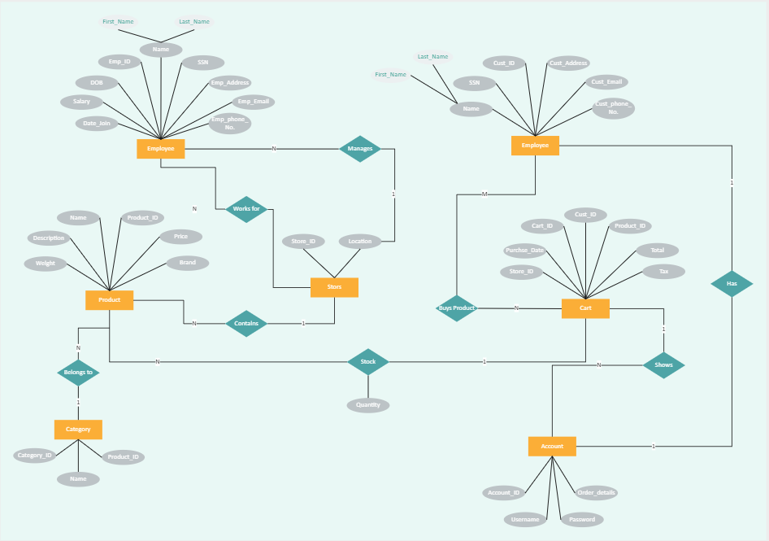

**Figure 3.1 ER Diagram**

**Users**:

**Attributes**: UserID (Primary Key), Username, Email, Password, Address, Phone Number

**Relationships**:

Users place Orders

Users have multiple Addresses

**Products**:

**Attributes**: ProductID (Primary Key), ProductName, Description, Price, Stock Quantity, CategoryID (Foreign Key)

**Relationships**:

Products belong to a Category

Products appear in multiple OrderItems

**Orders**:

**Attributes**: OrderID (Primary Key), UserID (Foreign Key), OrderDate, TotalAmount, Status

**Relationships**:

Orders are placed by Users

Orders contain multiple OrderItems

**Categories**:

**Attributes**: CategoryID (Primary Key), CategoryName, Description

**Relationships**:

Categories contain multiple Products

**OrderItems**:

**Attributes**: OrderItemID (Primary Key), OrderID (Foreign Key), ProductID (Foreign Key), Quantity, Price

**Relationships**:

OrderItems are part of Orders

OrderItems refer to Products

**Addresses**:

**Attributes**: AddressID (Primary Key), UserID (Foreign Key), AddressLine1, AddressLine2, City, State, PostalCode

**Relationships**:

Addresses belong to Users

The ER diagram provides a clear visualization of how data is structured and related within the database, ensuring data integrity and efficient data management.

### **3.2 Data Flow Diagram**

The Data Flow Diagram (DFD) illustrates the flow of information within the system, depicting how data moves between different processes and data stores. Here are the key components of the DFD:

**Level 0 - Context Diagram**:

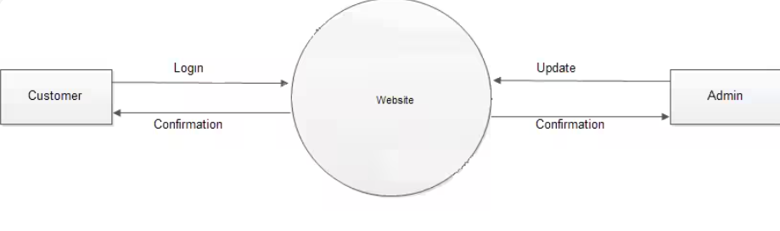**Figure 3.2 Level 0 DFD**

Shows the system as a single process and its interaction with external entities like Users and Payment Gateway.

**Level 1 - Decomposition Diagram**:

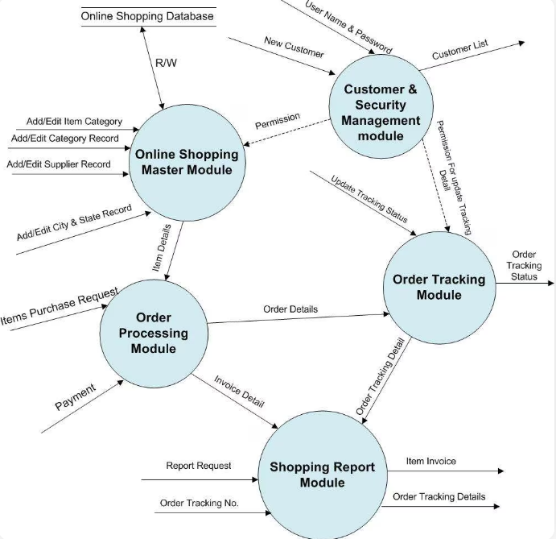

**Figure 3.3 Level 1 DFD**

Breaks down the main process into sub-processes such as User Registration, Product Browsing, Order Processing, and Payment Handling.

**User Registration**:

Input: User details (Username, Email, Password)

Process: Create User Account

Output: User confirmation email

**Product Browsing**:

Input: User search query or category selection

Process: Retrieve and display product listings

Output: Product details

**Order Processing**:

Input: User order details (selected products, quantities)

Process: Create Order, Update Inventory

Output: Order confirmation

**Payment Handling**:

Input: Payment details (credit card info, PayPal, etc.)

Process: Validate and process payment

Output: Payment confirmation

### **3.3 Use Case Diagram**

The Use Case Diagram provides a high-level view of the interactions between users and the system. It identifies the different types of users and their respective use cases. Here are the key components of the Use Case Diagram:

**Actors**:

**Customer**: A user who browses products, adds them to the cart, places orders, and tracks order status.

**Admin**: A user who manages the product catalog, processes orders, and handles customer inquiries.

**Delivery Personnel**: A user who manages and updates the status of deliveries.

**Use Cases**:

**Customer Use Cases**:

Register/Login: Customers register an account or log in to the system.

Browse Products: Customers browse and search for products.

Add to Cart: Customers add products to their shopping cart.

Place Order: Customers place an order for the items in their cart.

Track Order: Customers track the status of their orders.

Manage Profile: Customers update their personal information and address.

**Admin Use Cases**:

Manage Products: Admins add, update, or delete products from the catalog.

Process Orders: Admins manage order processing and inventory updates.

Handle Inquiries: Admins respond to customer inquiries and issues.

**Delivery Personnel Use Cases**:

Update Delivery Status: Delivery personnel update the status of deliveries.

View Delivery Routes: Delivery personnel view and manage their delivery routes.

The Use Case Diagram helps in understanding the system's functionality from a user's perspective, ensuring that all user requirements are captured and addressed during the development process.

## **CHAPTER 4**

## **SYSTEM DESIGN**

### **4.1 Architecture**

The architecture of the online grocery store is based on the MERN stack, providing a cohesive framework for development. Here are the key components of the system architecture:

**Frontend**:

**React.js**: The frontend is developed using React.js, which offers a component-based architecture for building dynamic user interfaces. React allows for the creation of reusable components, improving development efficiency and maintainability.

**Redux**: Redux is used for state management, ensuring a predictable and consistent application state. This helps manage the application's state across different components, making the UI responsive and interactive.

**Backend**:

**Node.js**: The backend is built using Node.js, a JavaScript runtime that enables the development of scalable server-side applications. Node.js handles multiple concurrent requests efficiently, making it suitable for real-time applications.

**Express.js**: Express.js, a web application framework for Node.js, simplifies the development of server-side logic and APIs. It provides a robust set of features for building web and mobile applications.

**Database**:

**MongoDB**: MongoDB is used as the database management system, storing structured data in a flexible, document-oriented format. MongoDB's schema-less design allows for easy modifications and scalability, handling large volumes of data effectively.

**Client-Server Interaction**:

**RESTful APIs**: The client (frontend) communicates with the server (backend) through RESTful APIs. These APIs handle various operations such as fetching product details, processing orders, and managing user authentication.

**AJAX**: Asynchronous JavaScript and XML (AJAX) is used to enable asynchronous communication between the client and server, providing a seamless and responsive user experience.

**Middleware**:

**Authentication Middleware**: Middleware functions handle user authentication and authorization, ensuring that only authenticated users can access certain features.

**Error Handling Middleware**: Middleware functions handle errors and exceptions, providing a consistent error handling mechanism across the application.

**Security**:

**HTTPS**: HTTPS is used to secure data transmission between clients and servers, protecting sensitive information such as user credentials and payment details.

**JWT (JSON Web Tokens)**: JWT is used for secure user authentication and session management. Tokens are issued upon successful login and are used to authenticate subsequent requests.

**Deployment**:

**Heroku**: The application is deployed on Heroku, a cloud platform that allows easy deployment, scaling, and management of applications. Heroku supports the entire MERN stack and provides a smooth deployment pipeline.

**Docker**: Docker is used to containerize the application, ensuring consistency across different environments. Docker containers package the application and its dependencies, making it easy to deploy and run.

### **4.2 Database Structure**

The database structure is designed to efficiently store and retrieve data related to products, users, orders, and other entities. Here are the key components of the database structure:

**Collections**:

**Users**: Stores user information such as UserID, Username, Email, Password, Address, and Phone Number.

**Products**: Stores product details such as ProductID, ProductName, Description, Price, Stock Quantity, and CategoryID.

**Orders**: Stores order information such as OrderID, UserID, OrderDate, TotalAmount, and Status.

**Categories**: Stores category information such as CategoryID, CategoryName, and Description.

**OrderItems**: Stores details of items in each order, including OrderItemID, OrderID, ProductID, Quantity, and Price.

**Addresses**: Stores user address details such as AddressID, UserID, AddressLine1, AddressLine2, City, State, and PostalCode.

**Indexes**:

Indexes are created on frequently queried fields to improve query performance. For example, indexes on UserID in the Orders collection and ProductID in the OrderItems collection.

**Relationships**:

Relationships between collections are managed using references. For example, the Orders collection references the Users collection through the UserID field, and the OrderItems collection references the Products collection through the ProductID field.

**Data Integrity**:

Data integrity is ensured through the use of unique constraints on fields such as UserID, ProductID, and OrderID. This prevents duplicate entries and maintains consistency in the database.

### **4.3 Component Interactions**

Component interactions refer to how different parts of the system communicate and work together to provide the desired functionality. Here are the key interactions within the system:

**Frontend and Backend**:

The frontend components, such as product listings and shopping cart, interact with backend APIs to fetch and update data. For example, when a user adds a product to the cart, the frontend sends a request to the backend API, which processes the request and updates the database.

**Backend and Database**:

The backend interacts with the MongoDB database to perform CRUD (Create, Read, Update, Delete) operations. For example, when a new user registers, the backend creates a new document in the Users collection.

Middleware functions in Express.js handle tasks such as authentication, logging, and error handling, ensuring that requests are processed securely and efficiently.

**External Services**:

Payment Gateway: The backend integrates with external payment gateways (e.g., Stripe, PayPal) to process payments securely. When a user makes a purchase, the payment details are sent to the payment gateway, which processes the transaction and returns a confirmation to the backend.

Email Services: The backend uses email services (e.g., SendGrid, Mailgun) to send transactional emails such as order confirmations and password resets. The backend sends the email content to the email service, which delivers the email to the user.

**User Authentication**:

The authentication middleware processes login requests by verifying user credentials against the data stored in the Users collection. Upon successful authentication, a JWT token is issued, which the frontend uses to authenticate subsequent requests.

Secure session management ensures that user data and activities are protected, with tokens being validated on each request to ensure they are still valid and not tampered with.

In conclusion, the system design of the online grocery store encompasses a well-structured architecture, efficient database design, and seamless component interactions. These elements work together to ensure the system is robust, scalable, and user-friendly, providing a high-quality online shopping experience.

### **4.3 Component Interactions**

Component interactions refer to how different parts of the system communicate and work together to provide the desired functionality. Here are the key interactions within the system:

**Frontend and Backend**:

The frontend components, such as product listings and shopping cart, interact with backend APIs to fetch and update data. For example, when a user adds a product to the cart, the frontend sends a request to the backend API, which processes the request and updates the database.

**Backend and Database**:

The backend interacts with the MongoDB database to perform CRUD (Create, Read, Update, Delete) operations. For example, when a new user registers, the backend creates a new document in the Users collection.

Middleware functions in Express.js handle tasks such as authentication, logging, and error handling, ensuring that requests are processed securely and efficiently.

**External Services**:

Payment Gateway: The backend integrates with external payment gateways (e.g., Stripe, PayPal) to process payments securely. When a user makes a purchase, the payment details are sent to the payment gateway, which processes the transaction and returns a confirmation to the backend.

Email Services: The backend uses email services (e.g., SendGrid, Mailgun) to send transactional emails such as order confirmations and password resets. The backend sends the email content to the email service, which delivers the email to the user.

**User Authentication**:

The authentication middleware processes login requests by verifying user credentials against the data stored in the Users collection. Upon successful authentication, a JWT token is issued, which the frontend uses to authenticate subsequent requests.

Secure session management ensures that user data and activities are protected, with tokens being validated on each request to ensure they are still valid and not tampered with.

In conclusion, the system design of the online grocery store encompasses a well-structured architecture, efficient database design, and seamless component interactions. These elements work together to ensure the system is robust, scalable, and user-friendly, providing a high-quality online shopping experience.

**CHAPTER 5**

## **FUTURE ENHANCEMENTS**

To continuously improve our online grocery app and stay ahead of the competition, we have identified several key areas for future enhancements. These enhancements aim to leverage advanced technology, provide a personalized experience, foster community engagement, and offer educational resources to users. Below are the detailed plans for each of these enhancements continuously improve our online grocery app and stay ahead of the competition, we have identified several key areas for future enhancements. These enhancements aim to leverage advanced technology, provide a personalized experience, foster community engagement, and offer educational resources to users. Below are the detailed plans for each of these enhancements:

### **5.1 Advanced Analytics**

Advanced analytics will play a crucial role in enhancing user experience and operational efficiency. By implementing sophisticated data analytics tools, we can gain deeper insights into user behavior, preferences, and trends. The following strategies will be employed:

**User Behavior Analysis:** Track and analyze user interactions with the app to understand purchasing patterns, preferred products, and peak usage times. This will help in optimizing product offerings and promotional strategies.

**Predictive Analytics:** Utilize machine learning algorithms to predict future shopping trends and user needs. This will enable proactive stocking of inventory and personalized product recommendations.

**Performance Monitoring:** Implement real-time monitoring of app performance to identify and address issues quickly. This includes tracking load times, error rates, and user drop-off points.

**Sales and Revenue Forecasting:** Use historical sales data to forecast future revenue and identify growth opportunities. This will assist in strategic planning and resource allocation.

### **5.2 Personalized Alerts and Notifications**

To enhance user engagement and satisfaction, we will introduce personalized alerts and notifications. These will be tailored to individual user preferences and shopping habits, providing relevant and timely information. Key features will include:

**Customized Promotions:** Send personalized discount offers and promotions based on past purchases and browsing history. This will encourage repeat purchases and increase customer loyalty.

**Order Status Updates:** Provide real-time notifications about order status, including confirmation, shipping, and delivery updates. This will improve transparency and reduce customer inquiries.

**Restock Alerts:** Notify users when out-of-stock items they are interested in become available again. This will help in retaining customers and boosting sales.

**Shopping Reminders:** Send reminders for recurring purchases, such as weekly groceries or monthly household supplies. This will make the shopping process more convenient for users.

### **5.3 Social Features and Community Engagement**

Building a strong community around our app can significantly enhance user experience and loyalty. By incorporating social features and promoting community engagement, we can create a platform where users can connect, share, and support each other. Planned features include:

**User Reviews and Ratings:** Allow users to rate and review products, providing valuable feedback to other customers and the app. This will help in maintaining high-quality standards and improving product offerings.

**Recipe Sharing and Recommendations:** Enable users to share their favorite recipes and discover new ones based on the ingredients they purchase. This will add value to their shopping experience and encourage exploration of new products.

**Community Forums:** Create forums where users can discuss topics related to cooking, healthy eating, and grocery shopping. This will foster a sense of community and provide a platform for knowledge sharing.

**Social Media Integration:** Integrate the app with popular social media platforms, allowing users to share their shopping experiences and product recommendations with friends and followers.

### **5.4 Enhanced User Customization Options**

Providing users with more customization options will make the app more user-friendly and tailored to individual needs. We plan to introduce several features that allow users to personalize their app experience:

**Customizable Home Screen:** Allow users to customize their home screen with shortcuts to their favorite categories, products, and features. This will make navigation more intuitive and efficient.

**Dietary Preferences and Restrictions:** Enable users to set dietary preferences and restrictions, such as vegetarian, gluten-free, or nut-free. The app will then filter and recommend products that meet these criteria.

**Shopping Lists:** Offer advanced shopping list features, such as the ability to create multiple lists, categorize items, and share lists with family members or friends. This will streamline the shopping process and enhance collaboration.

**Preferred Delivery Times:** Allow users to specify their preferred delivery times and schedule deliveries accordingly. This will provide greater convenience and flexibility.

### **5.5 Educational Resources and Learning Tools**

Empowering users with knowledge about food, nutrition, and cooking can significantly enhance their shopping experience and overall well-being. We aim to provide a range of educational resources and learning tools within the app:

**Shopping Reminders:** Send reminders for recurring purchases, such as weekly groceries or monthly household supplies. This will make the shopping process more convenient for users.

### **5.3 Social Features and Community Engagement**

Building a strong community around our app can significantly enhance user experience and loyalty. By incorporating social features and promoting community engagement, we can create a platform where users can connect, share, and support each other. Planned features include:

**User Reviews and Ratings:** Allow users to rate and review products, providing valuable feedback to other customers and the app. This will help in maintaining high-quality standards and improving product offerings.

**Recipe Sharing and Recommendations:** Enable users to share their favorite recipes and discover new ones based on the ingredients they purchase. This will add value to their shopping experience and encourage exploration of new products.

**Community Forums:** Create forums where users can discuss topics related to cooking, healthy eating, and grocery shopping. This will foster a sense of community and provide a platform for knowledge sharing.

**Social Media Integration:** Integrate the app with popular social media platforms, allowing users to share their shopping experiences and product recommendations with friends and followers.

### **5.4 Enhanced User Customization Options**

Providing users with more customization options will make the app more user-friendly and tailored to individual needs. We plan to introduce several features that allow users to personalize their app experience:

**Customizable Home Screen:** Allow users to customize their home screen with shortcuts to their favorite categories, products, and features. This will make navigation more intuitive and efficient.

**Dietary Preferences and Restrictions:** Enable users to set dietary preferences and restrictions, such as vegetarian, gluten-free, or nut-free. The app will then filter and recommend products that meet these criteria.

**Shopping Lists:** Offer advanced shopping list features, such as the ability to create multiple lists, categorize items, and share lists with family members or friends. This will streamline the shopping process and enhance collaboration.

**Preferred Delivery Times:** Allow users to specify their preferred delivery times and schedule deliveries accordingly. This will provide greater convenience and flexibility.

### **5.5 Educational Resources and Learning Tools**

Empowering users with knowledge about food, nutrition, and cooking can significantly enhance their shopping experience and overall well-being. We aim to provide a range of educational resources and learning tools within the app:

**Shopping Reminders:** Send reminders for recurring purchases, such as weekly groceries or monthly household supplies. This will make the shopping process more convenient for users.

### **5.3 Social Features and Community Engagement**

Building a strong community around our app can significantly enhance user experience and loyalty. By incorporating social features and promoting community engagement, we can create a platform where users can connect, share, and support each other. Planned features include:

**User Reviews and Ratings:** Allow users to rate and review products, providing valuable feedback to other customers and the app. This will help in maintaining high-quality standards and improving product offerings.

**Recipe Sharing and Recommendations:** Enable users to share their favorite recipes and discover new ones based on the ingredients they purchase. This will add value to their shopping experience and encourage exploration of new products.

**Community Forums:** Create forums where users can discuss topics related to cooking, healthy eating, and grocery shopping. This will foster a sense of community and provide a platform for knowledge sharing.

**Social Media Integration:** Integrate the app with popular social media platforms, allowing users to share their shopping experiences and product recommendations with friends and followers.

### **5.4 Enhanced User Customization Options**

Providing users with more customization options will make the app more user-friendly and tailored to individual needs. We plan to introduce several features that allow users to personalize their app experience:

**Customizable Home Screen:** Allow users to customize their home screen with shortcuts to their favorite categories, products, and features. This will make navigation more intuitive and efficient.

**Dietary Preferences and Restrictions:** Enable users to set dietary preferences and restrictions, such as vegetarian, gluten-free, or nut-free. The app will then filter and recommend products that meet these criteria.

**Shopping Lists:** Offer advanced shopping list features, such as the ability to create multiple lists, categorize items, and share lists with family members or friends. This will streamline the shopping process and enhance collaboration.

**Preferred Delivery Times:** Allow users to specify their preferred delivery times and schedule deliveries accordingly. This will provide greater convenience and flexibility.

### **5.5 Educational Resources and Learning Tools**

Empowering users with knowledge about food, nutrition, and cooking can significantly enhance their shopping experience and overall well-being. We aim to provide a range of educational resources and learning tools within the app:

**Nutritional Information:** Display detailed nutritional information for all products, helping users make informed choices about their purchases. This will be particularly useful for health-conscious customers.

**Cooking Tutorials:** Offer video tutorials and step-by-step guides for preparing various dishes. This will inspire users to try new recipes and make better use of the products they purchase.

**Healthy Eating Tips:** Provide tips and articles on healthy eating habits, meal planning, and maintaining a balanced diet. This will support users in their health and wellness goals.

**Seasonal and Local Produce Guides:** Educate users about the benefits of seasonal and locally sourced produce. This will encourage sustainable shopping practices and support local farmers.

By implementing these future enhancements, we aim to create a more engaging, personalized, and informative shopping experience for our users. These improvements will not only meet the evolving needs of our customers but also position our app as a leader in the online grocery market.

**CHAPTER 6**

## **IMPLEMENTATION**

The successful implementation of our online grocery app's enhancements requires a detailed and structured approach. This section outlines the critical implementation aspects, including real-time price monitoring, improved search functionality, and robust user authentication. Each component is essential for ensuring a seamless, secure, and efficient user experience.

### **6.1 Real-Time Price Monitoring**

Real-time price monitoring is essential for maintaining competitive pricing and enhancing customer trust. This feature involves continuously tracking and updating product prices based on various factors such as market trends, competitor pricing, and supply chain changes. The following steps outline the implementation process:

#### **Data Integration and Sources**

**Data Aggregation:** Integrate data from multiple sources, including suppliers, competitors, and market analysis tools. This will involve setting up APIs and data scraping mechanisms to collect real-time price data.

**Supplier Integration:** Establish direct connections with suppliers to receive real-time updates on product prices and availability. This ensures that our pricing reflects the latest changes in the supply chain.

#### **Real-Time Processing**

**Automated Algorithms:** Develop algorithms to automatically adjust prices based on the collected data. These algorithms will consider factors such as demand, inventory levels, and competitor pricing to determine optimal prices.

**Dynamic Pricing Engine:** Implement a dynamic pricing engine that can process data in real-time and adjust prices accordingly. This engine will ensure that prices are updated instantly across the platform.

#### **User Interface**

**Price Display:** Ensure that the user interface reflects real-time price changes without any delays. This involves updating the product listing pages, shopping cart, and checkout process to display the latest prices.

**Price Alerts:** Provide users with notifications about significant price changes for their favorite or frequently purchased products. This feature will enhance transparency and encourage repeat purchases.

#### **Testing and Monitoring**

**A/B Testing:** Conduct A/B testing to assess the impact of real-time price changes on user behavior and sales. This will help fine-tune the pricing algorithms for optimal performance.

**Performance Monitoring:** Continuously monitor the performance of the price monitoring system to identify and resolve any issues. This includes tracking the accuracy of price updates, system latency, and user feedback.

### **6.2 Search Functionality**

Enhanced search functionality is critical for providing users with a fast, accurate, and intuitive way to find products. The implementation of an advanced search system involves several key components:

#### **Search Algorithm Improvement**

**Relevance Ranking:** Develop a sophisticated relevance ranking algorithm that considers various factors such as keyword match, product popularity, user preferences, and purchase history. This will ensure that the most relevant products appear at the top of search results.

**Natural Language Processing (NLP):** Implement NLP techniques to understand and process user queries more effectively. This will enable the search system to handle complex queries, synonyms, and common misspellings.

#### **Filters and Sorting Options**

**Dynamic Filters:** Provide users with dynamic filtering options based on categories, brands, price ranges, dietary preferences, and other attributes. These filters will allow users to narrow down search results to meet their specific needs.

**Advanced Sorting:** Offer advanced sorting options such as relevance, price (low to high and high to low), customer ratings, and newest arrivals. This will help users quickly find the products that best match their criteria.

#### **Autocomplete and Suggestions**

**Autocomplete Functionality:** Implement an autocomplete feature that suggests relevant search terms as users type. This will speed up the search process and help users find products even if they are unsure of the exact name.

**Personalized Suggestions:** Provide personalized product suggestions based on users’ past searches, browsing history, and purchase behavior. This will make the search experience more tailored and efficient.

#### **User Experience Enhancements**

**Responsive Design:** Ensure that the search functionality is responsive and works seamlessly across different devices, including desktops, tablets, and smartphones.

**Search Analytics:** Collect and analyze data on search queries, user interactions, and search result performance. Use this data to continuously improve the search algorithm and user experience.

#### **Testing and Optimization**

**Usability Testing:** Conduct extensive usability testing to identify and address any issues with the search functionality. This includes testing with diverse user groups to ensure that the search system meets the needs of all users.

**Continuous Optimization:** Regularly update and optimize the search algorithms based on user feedback and performance data. This will help maintain high levels of accuracy and relevance over time.

### **6.3 User Authentication**

Robust user authentication is crucial for ensuring the security and privacy of our users. Implementing a secure and user-friendly authentication system involves several key elements:

#### **Authentication Methods**

**Email and Password:** Implement a standard email and password-based authentication system. Ensure that passwords are stored securely using hashing and salting techniques.

#### **Data Integration and Sources**

**Data Aggregation:** Integrate data from multiple sources, including suppliers, competitors, and market analysis tools. This will involve setting up APIs and data scraping mechanisms to collect real-time price data.

**Supplier Integration:** Establish direct connections with suppliers to receive real-time updates on product prices and availability. This ensures that our pricing reflects the latest changes in the supply chain.

#### **Real-Time Processing**

**Automated Algorithms:** Develop algorithms to automatically adjust prices based on the collected data. These algorithms will consider factors such as demand, inventory levels, and competitor pricing to determine optimal prices.

**Dynamic Pricing Engine:** Implement a dynamic pricing engine that can process data in real-time and adjust prices accordingly. This engine will ensure that prices are updated instantly across the platform.

#### **User Interface**

**Price Display:** Ensure that the user interface reflects real-time price changes without any delays. This involves updating the product listing pages, shopping cart, and checkout process to display the latest prices.

**Price Alerts:** Provide users with notifications about significant price changes for their favorite or frequently purchased products. This feature will enhance transparency and encourage repeat purchases.

#### **Testing and Monitoring**

**A/B Testing:** Conduct A/B testing to assess the impact of real-time price changes on user behavior and sales. This will help fine-tune the pricing algorithms for optimal performance.

**Performance Monitoring:** Continuously monitor the performance of the price monitoring system to identify and resolve any issues. This includes tracking the accuracy of price updates, system latency, and user feedback.

### **6.2 Search Functionality**

Enhanced search functionality is critical for providing users with a fast, accurate, and intuitive way to find products. The implementation of an advanced search system involves several key components:

#### **Search Algorithm Improvement**

**Relevance Ranking:** Develop a sophisticated relevance ranking algorithm that considers various factors such as keyword match, product popularity, user preferences, and purchase history. This will ensure that the most relevant products appear at the top of search results.

**Natural Language Processing (NLP):** Implement NLP techniques to understand and process user queries more effectively. This will enable the search system to handle complex queries, synonyms, and common misspellings.

#### **Filters and Sorting Options**

**Dynamic Filters:** Provide users with dynamic filtering options based on categories, brands, price ranges, dietary preferences, and other attributes. These filters will allow users to narrow down search results to meet their specific needs.

**Advanced Sorting:** Offer advanced sorting options such as relevance, price (low to high and high to low), customer ratings, and newest arrivals. This will help users quickly find the products that best match their criteria.

#### **Autocomplete and Suggestions**

**Autocomplete Functionality:** Implement an autocomplete feature that suggests relevant search terms as users type. This will speed up the search process and help users find products even if they are unsure of the exact name.

**Personalized Suggestions:** Provide personalized product suggestions based on users’ past searches, browsing history, and purchase behavior. This will make the search experience more tailored and efficient.

#### **User Experience Enhancements**

**Responsive Design:** Ensure that the search functionality is responsive and works seamlessly across different devices, including desktops, tablets, and smartphones.

**Search Analytics:** Collect and analyze data on search queries, user interactions, and search result performance. Use this data to continuously improve the search algorithm and user experience.

#### **Testing and Optimization**

**Usability Testing:** Conduct extensive usability testing to identify and address any issues with the search functionality. This includes testing with diverse user groups to ensure that the search system meets the needs of all users.

**Continuous Optimization:** Regularly update and optimize the search algorithms based on user feedback and performance data. This will help maintain high levels of accuracy and relevance over time.

### **6.3 User Authentication**

Robust user authentication is crucial for ensuring the security and privacy of our users. Implementing a secure and user-friendly authentication system involves several key elements:

#### **Authentication Methods**

**Email and Password:** Implement a standard email and password-based authentication system. Ensure that passwords are stored securely using hashing and salting techniques.

**Multi-Factor Authentication (MFA):** Introduce MFA to add an extra layer of security. This can include SMS-based verification codes, email-based verification, or app-based authentication (e.g., Google Authenticator).

**Social Media Login:** Provide users with the option to log in using their social media accounts (e.g., Facebook, Google). This will offer convenience while ensuring secure authentication through OAuth protocols.

#### **Security Measures**

**Encryption:** Ensure that all user data, including passwords and personal information, is transmitted and stored using strong encryption protocols (e.g., TLS for data in transit and AES for data at rest).

**Account Recovery:** Implement secure account recovery options, such as email-based password resets and security questions. Ensure that the recovery process is both user-friendly and secure.

**Session Management:** Use secure session management practices, including session timeouts and automatic logout after periods of inactivity. This will help protect user accounts from unauthorized access.

#### **User Experience**

**User-Friendly Interface:** Design an intuitive and user-friendly authentication interface. This includes clear instructions, error messages, and a smooth registration and login process.

**Accessibility:** Ensure that the authentication process is accessible to all users, including those with disabilities. This involves following accessibility guidelines (e.g., WCAG) and providing support for assistive technologies.

#### **Monitoring and Compliance**

**Activity Monitoring:** Continuously monitor authentication activity to detect and respond to suspicious behavior. Implement automated alerts and responses for potential security threats.

**Regulatory Compliance:** Ensure that the authentication system complies with relevant data protection regulations (e.g., GDPR, CCPA). This includes obtaining user consent and providing options for data access and deletion.

#### **Testing and Maintenance**

**Security Audits:** Conduct regular security audits and penetration testing to identify and address vulnerabilities in the authentication system.

**User Feedback:** Collect and analyze user feedback on the authentication process to identify areas for improvement. Use this feedback to enhance both security and user experience.

By meticulously implementing these features, our online grocery app will provide a secure, efficient, and user-friendly experience, thereby fostering customer trust and satisfaction.

**CHAPTER 7**

## **TESTING**

Thorough testing is essential for ensuring the reliability, security, and usability of our online grocery app. This section outlines a comprehensive testing strategy that covers all critical aspects of the application, from functionality and performance to security and user experience.

### **7.1 Functional Testing**

Functional testing ensures that the app's features work as intended and meet the specified requirements. This involves several types of tests:

#### **Unit Testing**

**Objective:** Verify that individual components and functions of the app work correctly in isolation.

**Method:** Developers will write and run automated unit tests using testing frameworks such as Jest, Mocha, or NUnit. These tests will cover core functionalities like adding items to the cart, processing payments, and user authentication.

**Scope:** Every function, method, and class should have corresponding unit tests. For example, tests will be written to check the accuracy of the price calculation algorithm, the correct display of search results, and the proper handling of user input.

#### **Integration Testing**

**Objective:** Ensure that different components of the app work together seamlessly.

**Method:** Automated integration tests will be conducted to validate the interaction between various modules, such as the shopping cart, payment gateway, and inventory management system.

**Scope:** Tests will cover scenarios like processing a complete order from product selection to payment confirmation, ensuring that all parts of the system communicate and function together correctly.

#### **System Testing**

**Objective:** Validate the entire system's functionality as a whole.

**Method:** Comprehensive end-to-end testing will be performed to simulate real user scenarios and workflows. This includes testing the complete user journey from account registration and product search to checkout and order tracking.

**Scope:** All major features and user paths will be tested, including edge cases and error handling. For instance, testing will include scenarios such as handling multiple simultaneous orders, processing refunds, and managing inventory updates.

### **7.2 Performance Testing**

Performance testing ensures that the app can handle the expected load and perform well under various conditions. This includes:

#### **Load Testing**

**Objective:** Assess how the app performs under expected user load.

**Method:** Simulate a typical number of concurrent users to test the system's response time, throughput, and stability. Tools like Apache JMeter, LoadRunner, or Gatling will be used.

**Scope:** Test scenarios will include normal usage patterns, such as browsing products, adding items to the cart, and completing purchases during peak hours.

#### **Stress Testing**

**Objective:** Determine the app's behavior under extreme conditions.

**Method:** Simulate high traffic loads that exceed normal operational capacity to identify breaking points and ensure graceful degradation.

**Scope:** Scenarios will include unexpected surges in traffic, such as during major promotions or sales events, to ensure the app can handle sudden spikes in usage.

#### **Scalability Testing**

**Objective:** Evaluate the app's ability to scale and handle increased loads.

**Method:** Gradually increase the number of users and transactions to observe how the system scales and where potential bottlenecks arise.

**Scope:** Focus on critical components like the database, server load, and network bandwidth to ensure they can scale efficiently with increased demand.

### **7.3 Security Testing**

Security testing is crucial for protecting user data and ensuring the app is secure against vulnerabilities. This includes:

#### **Vulnerability Scanning**

**Objective:** Identify security weaknesses and vulnerabilities.

**Method:** Use automated tools like OWASP ZAP, Nessus, or Burp Suite to scan the app for common vulnerabilities such as SQL injection, XSS (Cross-Site Scripting), and CSRF (Cross-Site Request Forgery).

**Scope:** Regular scans will be performed on all parts of the application, especially those handling sensitive data like user authentication and payment processing.

#### **Penetration Testing**

**Objective:** Simulate real-world attacks to evaluate the app's security defenses.

**Method:** Security experts will conduct manual penetration tests to exploit potential vulnerabilities and assess the system's response.

**Scope:** Focus areas will include the authentication system, data encryption methods, and secure communication protocols.

#### **Compliance Testing**

**Objective:** Ensure the app complies with relevant security standards and regulations.

**Method:** Review and test the app against standards such as GDPR, CCPA, and PCI-DSS.

**Scope:** All aspects of data handling, storage, and transmission will be examined to ensure compliance with legal and regulatory requirements.

### **7.4 Usability Testing**

Usability testing ensures that the app is user-friendly and meets the needs of its target audience. This includes:

#### **User Testing**

**Objective:** Evaluate the app's ease of use and overall user experience.

**Method:** Conduct user testing sessions where participants perform typical tasks on the app while providing feedback on their experience.

**Scope:** Tasks will include account creation, product search, checkout process, and navigation. Feedback will be collected on ease of use, clarity of instructions, and overall satisfaction.

#### **A/B Testing**

**Objective:** Compare different versions of the app to determine which performs better.

**Method:** Implement A/B testing to compare user interactions with different design elements or features.

**Scope:** Test variations in user interface design, navigation flow, and promotional offers to optimize for user engagement and conversion rates.

#### **Accessibility Testing**

**Objective:** Ensure the app is accessible to all users, including those with disabilities.

**Method:** Use tools like WAVE, Axe, and manual testing with assistive technologies to verify compliance with accessibility standards (e.g., WCAG).

**Scope:** Test for keyboard navigation, screen reader compatibility, and color contrast to ensure the app is usable by everyone.

### **7.5 Regression Testing**

Regression testing ensures that new changes or updates do not introduce new bugs or negatively impact existing functionalities. This includes:

#### **Automated Regression Testing**

**Objective:** Quickly identify any issues introduced by code changes.

**Method:** Develop and run automated regression tests using continuous integration tools like Jenkins or Travis CI.

**Scope:** Test all critical paths and features to ensure they work as expected after each update or bug fix.

#### **Manual Regression Testing**

**Objective:** Complement automated tests with detailed, human-led examination.

**Method:** Perform manual regression testing for complex scenarios or areas where automated testing may fall short.

**Scope:** Focus on areas most affected by recent changes, ensuring that new updates do not disrupt existing functionality.

By implementing this comprehensive testing strategy, we will ensure that our online grocery app is robust, secure, and user-friendly, providing a reliable and satisfying experience for all users.

**CHAPTER 8**

**SNAPSHOT**

**8.1 Signup:**

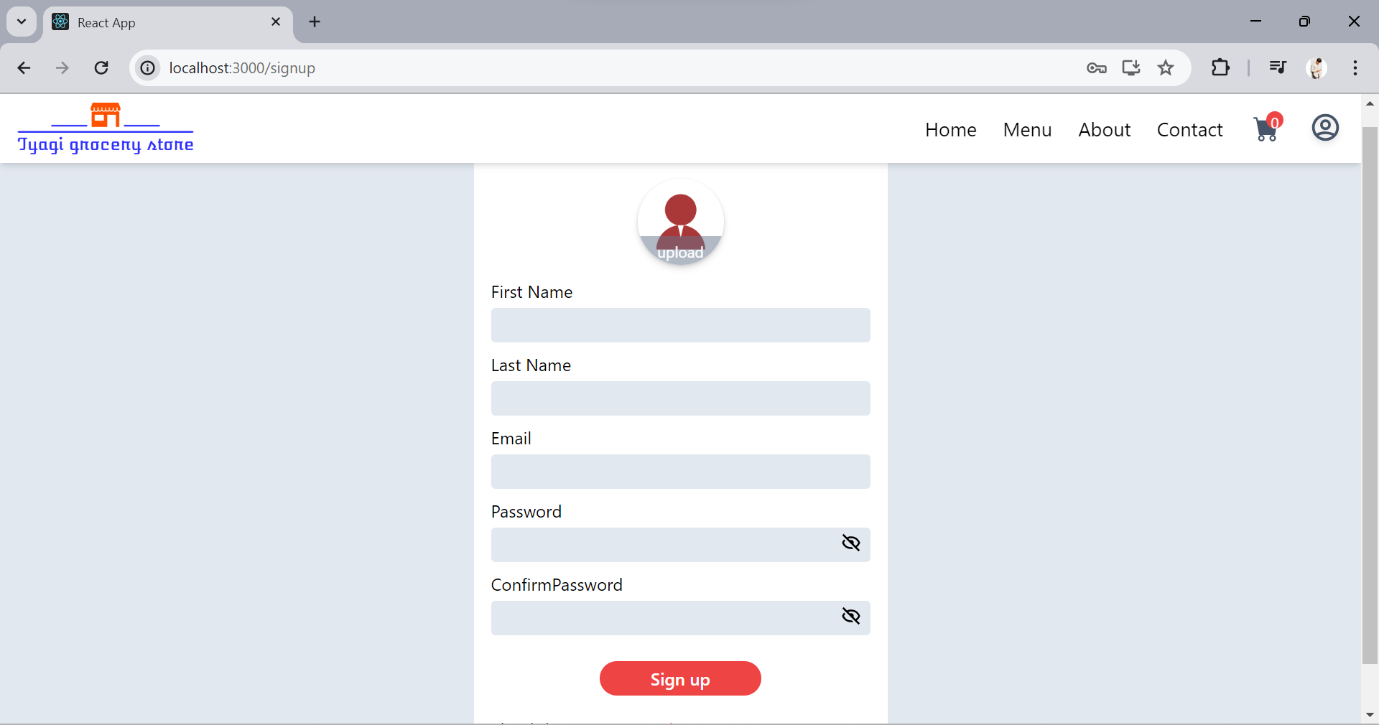

**Figure 8.1 Signup Page**

**8.2 Login:**

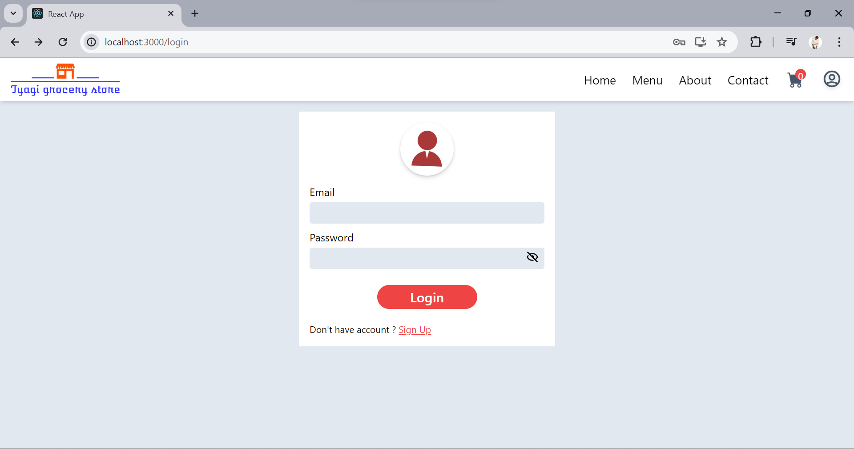

**Figure 8.2 Login Page**

**8.3 Home:**

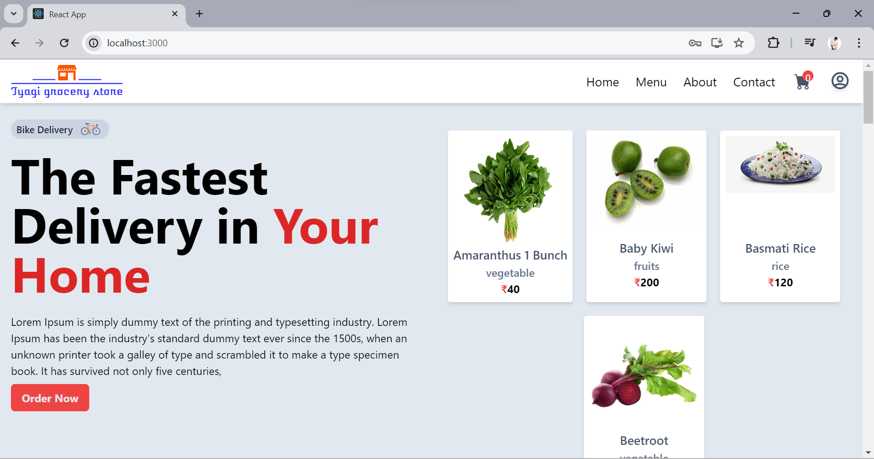

**Figure 8.3 Home Page**

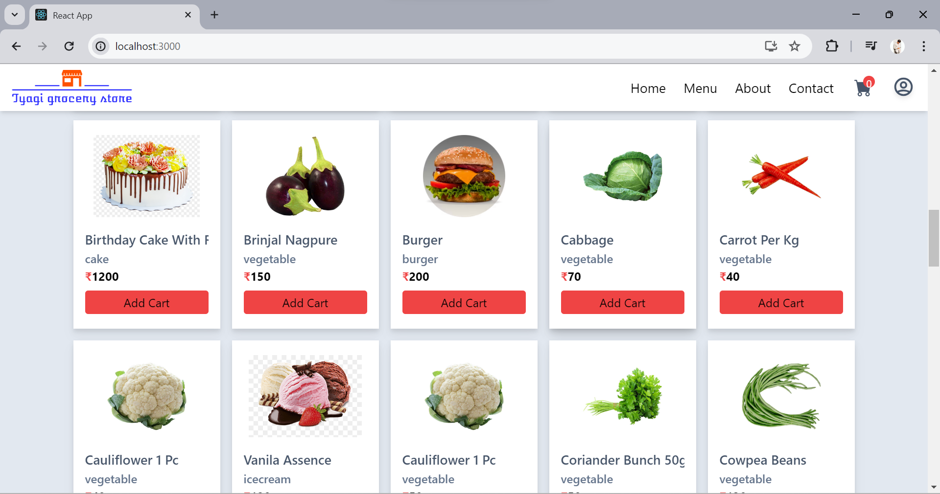

**Figure 8.4 Home Page**

**8.4 Menu:**

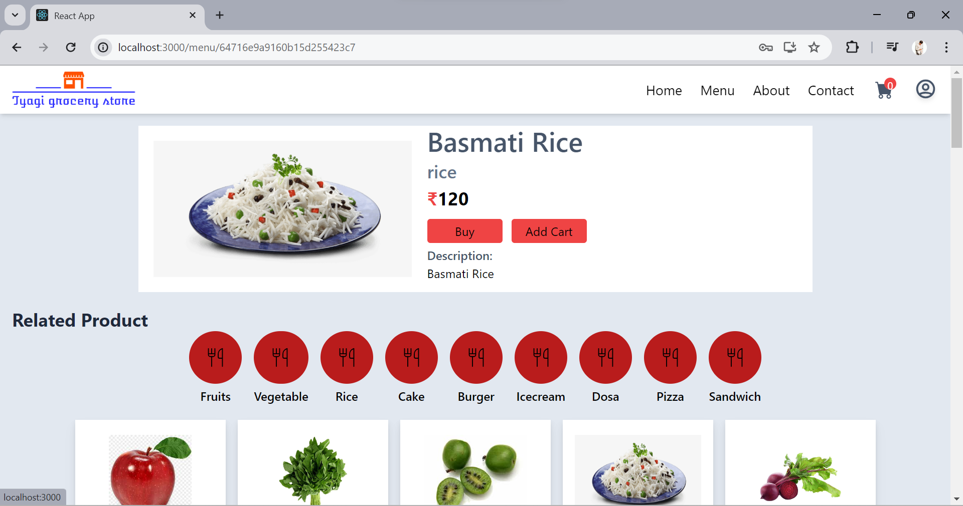

**Figure 8.5 Menu Page**

**8.5 Contact :**

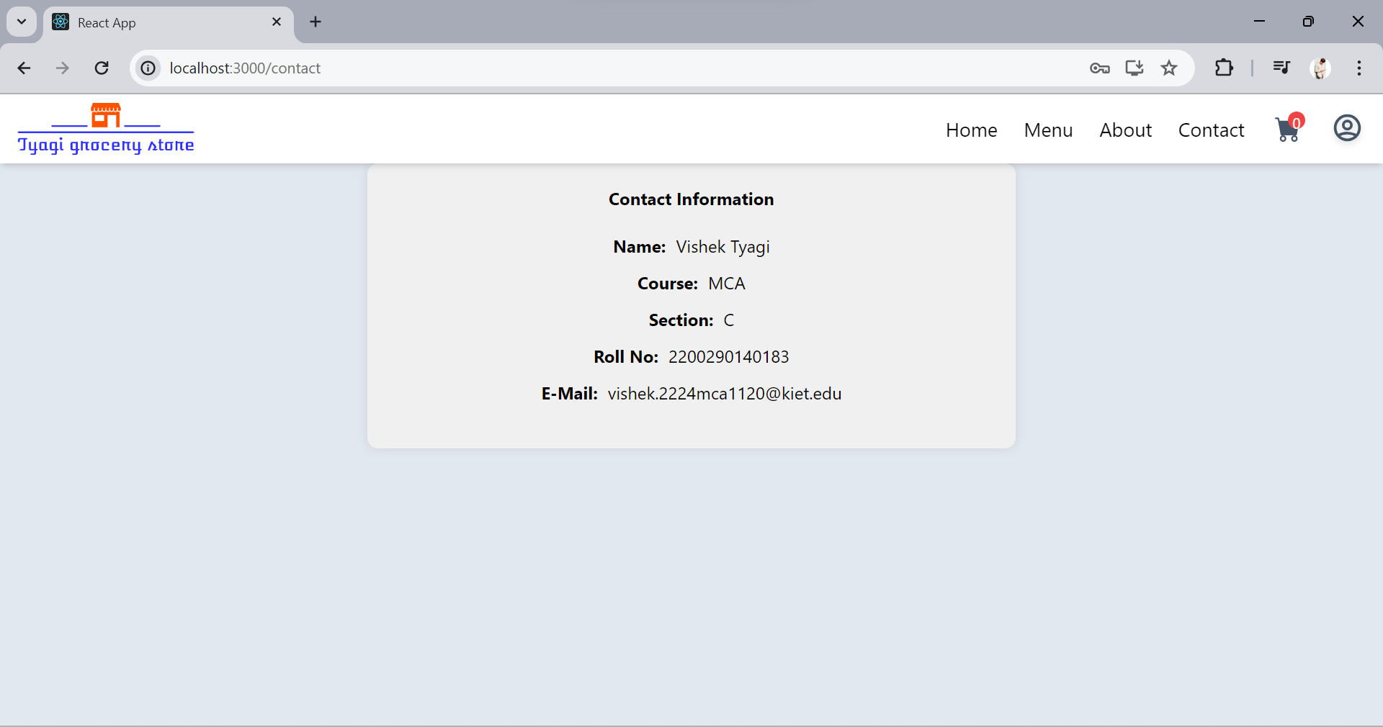

**Figure 8.6 Contact Page**

**8.6 About:**

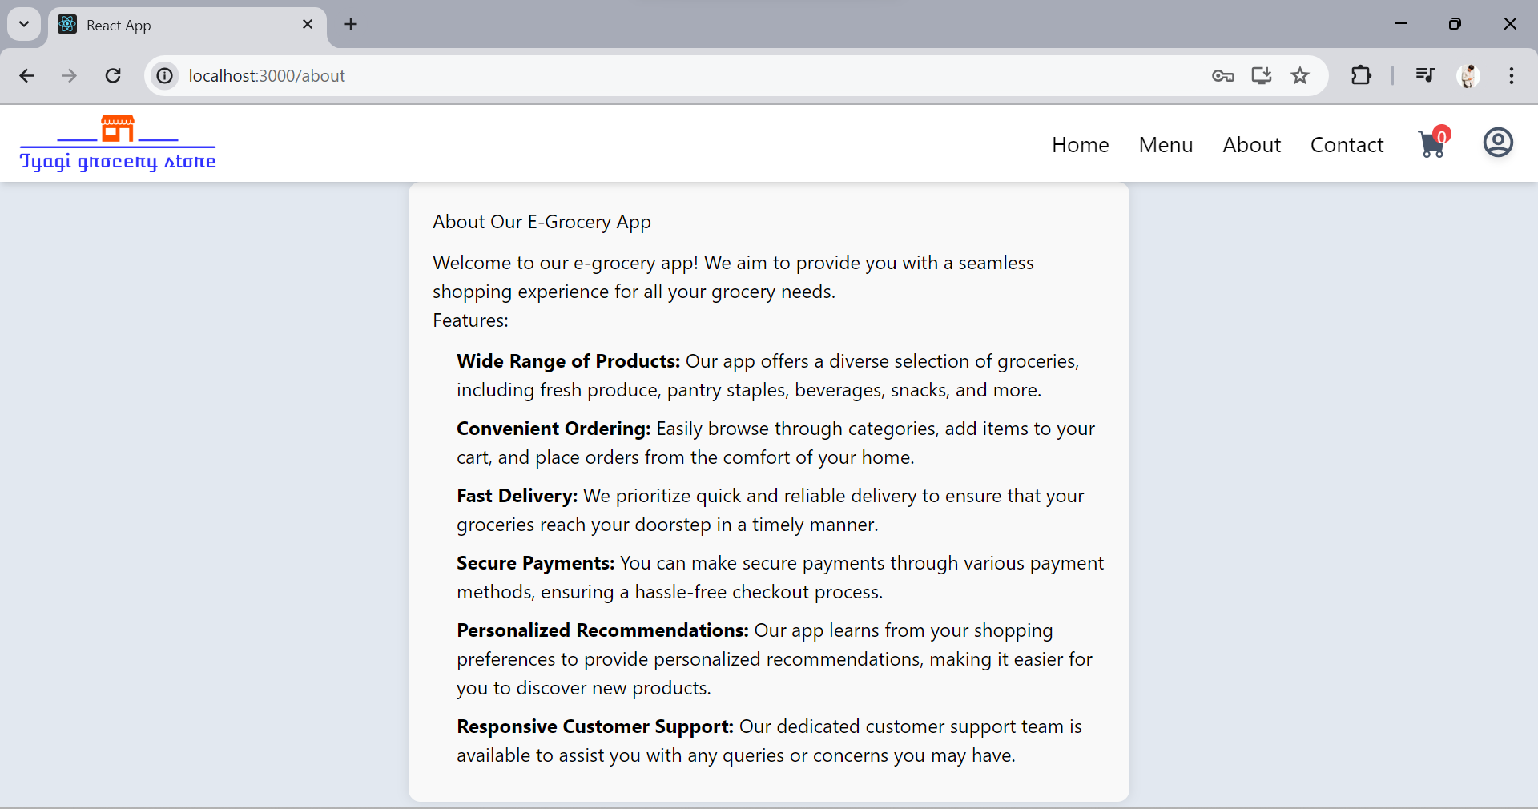

**Figure 8.7 About Page**

**8.7 Cart :**

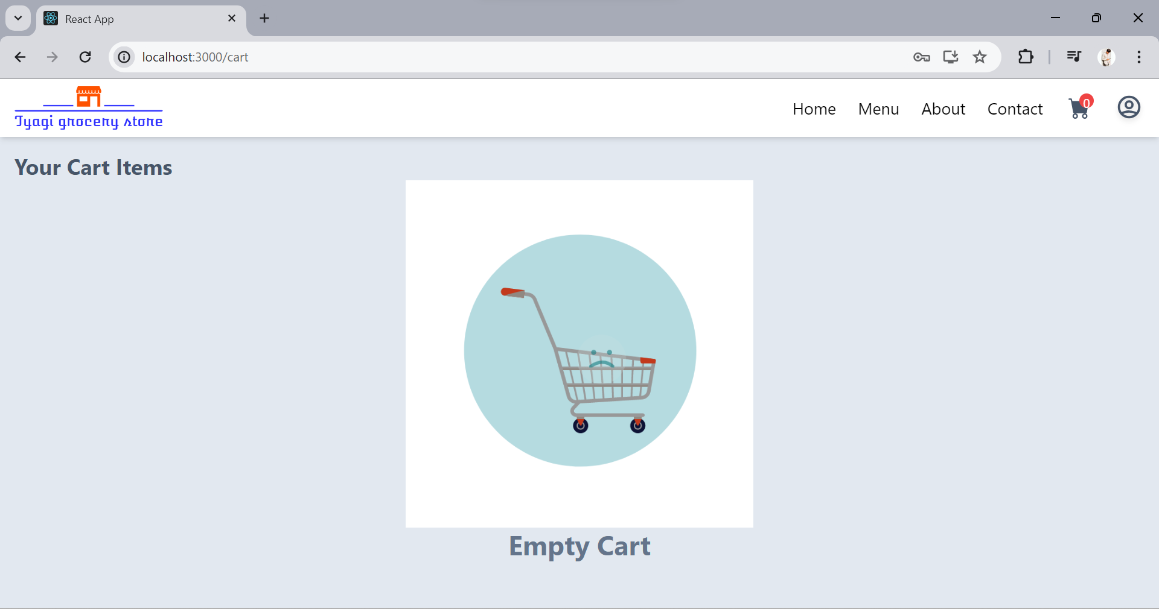

**Figure 8.8Cart Page**

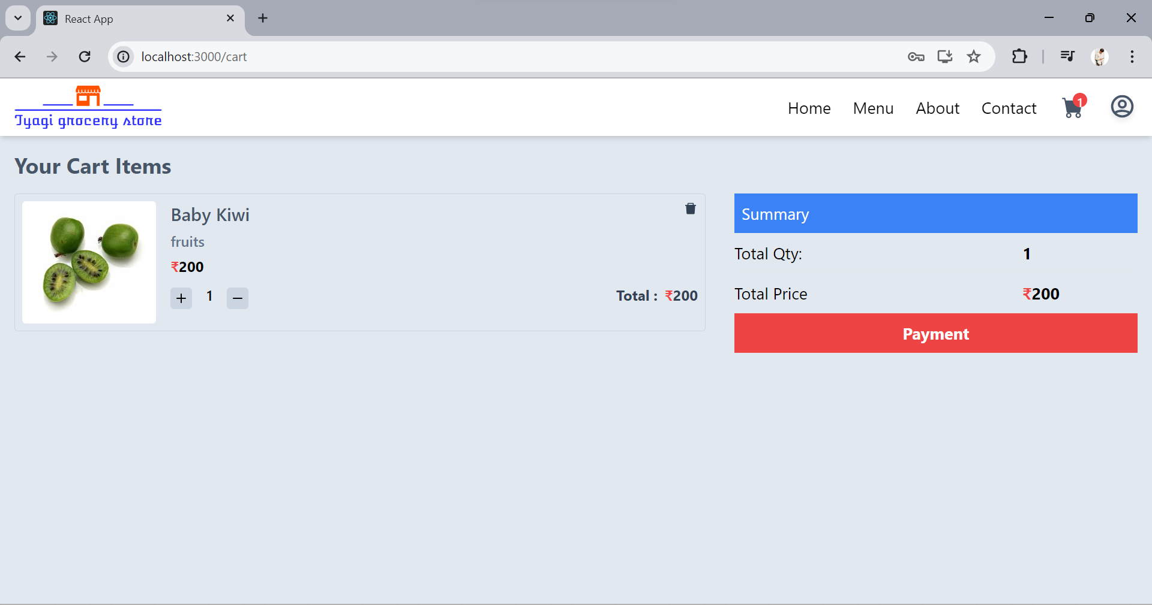

**Figure 8.9 Cart Page**

**8.8 Payment :**

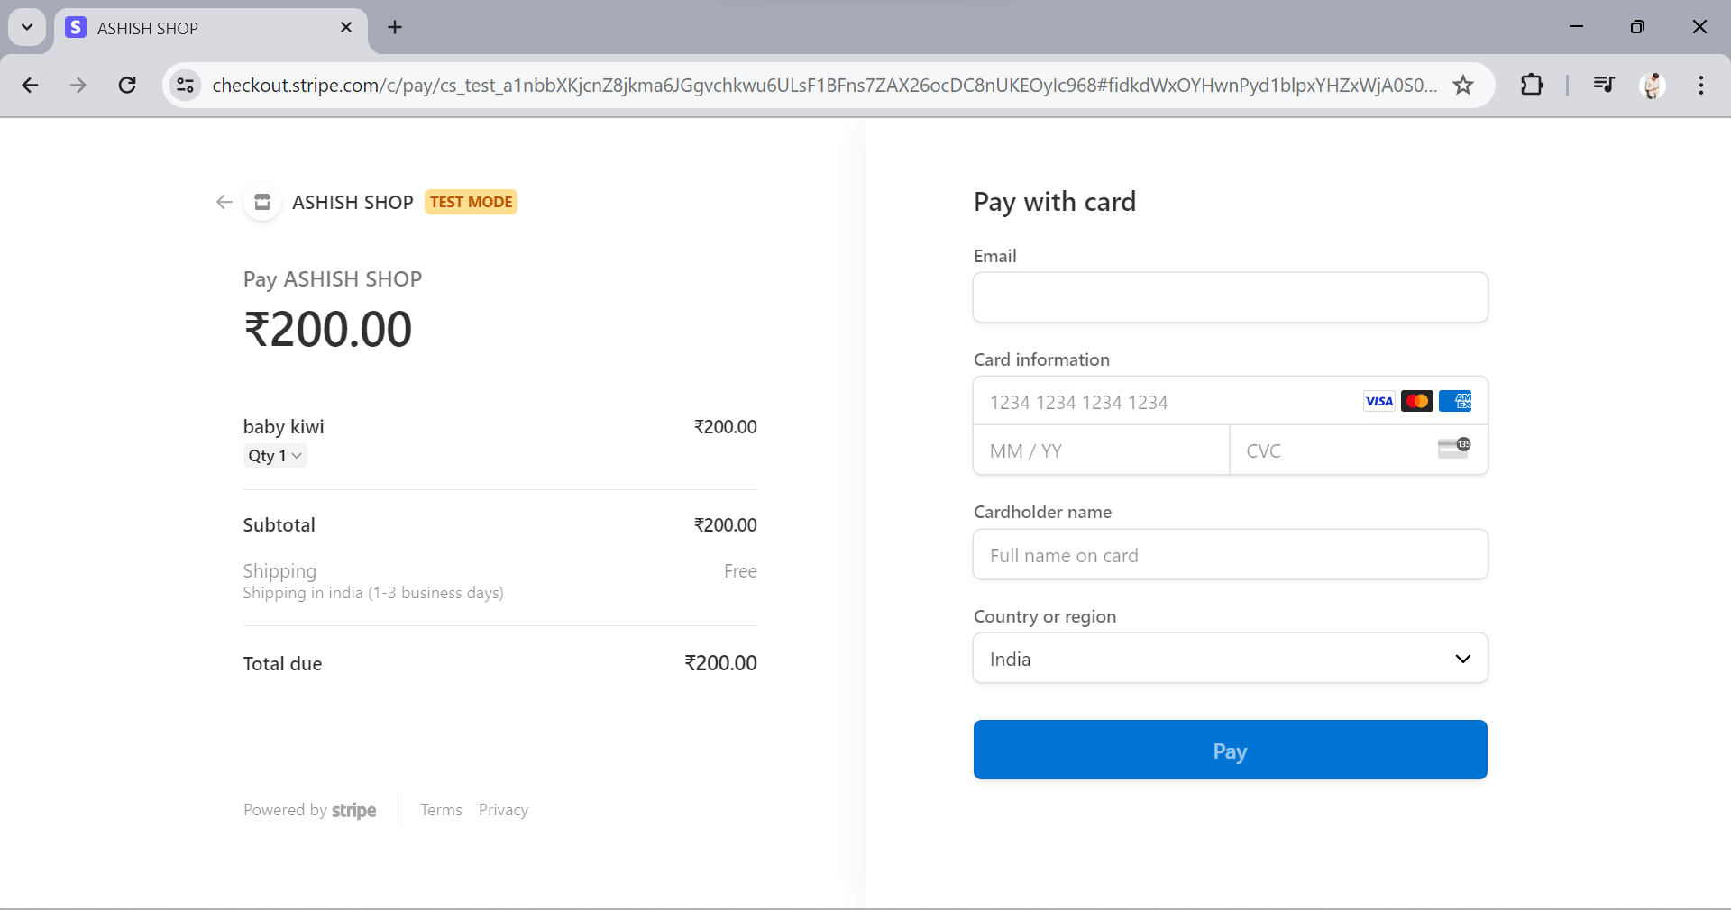

**Figure 8.10 Payment Page**

**CHAPTER 9**

## **CONCLUSION**

The conclusion of our comprehensive project report on the development and enhancement of our online grocery app synthesizes the various strategies, implementations, and testing phases that we have meticulously executed to ensure a robust, user-friendly, and innovative platform. This detailed overview encapsulates the critical elements of our project, highlighting how each aspect contributes to the overall success and future readiness of our app.

### **Strategic Enhancements**

Our online grocery app has been enhanced with several strategic features aimed at elevating user experience and engagement. These enhancements, which include advanced analytics, personalized alerts and notifications, social features, user customization options, and educational resources, are designed to address the diverse needs of our users and provide them with a seamless and enriched shopping experience.

#### **Advanced Analytics**

By integrating advanced analytics, we can gain deeper insights into user behavior, preferences, and trends. This data-driven approach allows us to tailor our offerings and services to better meet user demands. Predictive analytics enable us to anticipate future shopping trends and stock inventory proactively, ensuring that we are always prepared to meet user needs.

#### **Personalized Alerts and Notifications**

Personalized alerts and notifications enhance user engagement by providing timely and relevant information. Customized promotions based on past purchases encourage repeat business, while real-time order status updates improve transparency and customer satisfaction. Additionally, restock alerts and shopping reminders make the shopping process more convenient and user-friendly.

#### **Social Features and Community Engagement**

Building a strong community around our app fosters user loyalty and engagement. Features such as user reviews, recipe sharing, community forums, and social media integration create a platform where users can connect, share, and support each other. These social features not only enhance the user experience but also drive organic growth through word-of-mouth and social sharing.

#### **Enhanced User Customization Options**

Providing users with more customization options allows them to tailor the app to their specific needs. Customizable home screens, dietary preferences, advanced shopping list features, and preferred delivery times offer a personalized experience that enhances user satisfaction and retention.

#### **Educational Resources and Learning Tools**

Empowering users with knowledge about food, nutrition, and cooking enhances their overall experience and well-being. Detailed nutritional information, cooking tutorials, healthy eating tips, and guides on seasonal and local produce help users make informed choices and discover new culinary possibilities.

### **Implementation Strategy**

The successful implementation of these enhancements relies on a detailed and structured approach. Our implementation strategy focuses on three critical areas: real-time price monitoring, improved search functionality, and robust user authentication.

#### **Real-Time Price Monitoring**

Real-time price monitoring ensures competitive pricing and enhances customer trust. By integrating data from multiple sources, using automated algorithms, and implementing a dynamic pricing engine, we can maintain accurate and up-to-date prices. User interfaces are designed to reflect real-time changes seamlessly, and performance monitoring ensures system reliability.

#### **Search Functionality**

Enhanced search functionality is crucial for providing a fast, accurate, and intuitive way to find products. Our improved search system includes relevance ranking algorithms, natural language processing, dynamic filters, advanced sorting options, and personalized suggestions. Usability testing and continuous optimization ensure that the search experience remains efficient and user-friendly.

#### **User Authentication**

Robust user authentication is essential for security and privacy. Our authentication system includes standard email and password login, multi-factor authentication, and social media login options. Security measures such as encryption, secure account recovery, and session management protect user data. Compliance with regulatory standards and regular security audits ensure ongoing security and compliance.

### **Comprehensive Testing**

Thorough testing is vital for ensuring the reliability, security, and usability of our app. Our comprehensive testing strategy includes functional, performance, security, usability, and regression testing.

#### **Functional Testing**

Functional testing verifies that the app's features work as intended. This includes unit testing, integration testing, and system testing. Automated and manual tests cover all critical functionalities and user workflows, ensuring that the app performs correctly under various scenarios.

#### **Performance Testing**

Performance testing assesses the app's ability to handle expected loads and perform well under various conditions. Load testing, stress testing, and scalability testing ensure that the app remains stable and responsive during peak usage and can scale efficiently with increased demand.

#### **Security Testing**

Security testing protects user data and ensures the app is secure against vulnerabilities. Vulnerability scanning, penetration testing, and compliance testing identify and address security weaknesses. Regular security audits and adherence to regulatory standards maintain a high level of security.

#### **Usability Testing**

Usability testing ensures that the app is user-friendly and meets the needs of its target audience. User testing, A/B testing, and accessibility testing evaluate the app's ease of use, design, and accessibility. Feedback from these tests informs ongoing improvements to enhance user experience.

#### **Regression Testing**

Regression testing ensures that new changes or updates do not introduce new bugs or negatively impact existing functionalities. Automated and manual regression tests cover all critical paths and features, ensuring that the app remains stable and reliable after each update.

### **Continuous Improvement and Future Readiness**

Our commitment to continuous improvement ensures that our online grocery app remains competitive and aligned with user needs. By leveraging user feedback, technological advancements, and market trends, we will continue to refine and enhance our app. Future enhancements will focus on further personalization, advanced technology integration, and expanding our community and educational resources.

### **Conclusion**

The development and enhancement of our online grocery app have been guided by a strategic vision to provide a comprehensive, user-friendly, and secure shopping experience. Through detailed planning, robust implementation, and thorough testing, we have created an app that meets the evolving needs of our users and positions us for future growth and innovation.

By continuously refining our app based on user feedback and technological advancements, we are committed to maintaining high standards of quality and customer satisfaction. These enhancements not only address current market demands but also position our app as a leader in the online grocery market. As we move forward, we will continue to prioritize user needs and leverage cutting-edge technology to deliver an exceptional online grocery shopping experience.

**CHAPTER 10**

**REFERENCES**

1. React.js Documentation. Retrieved from: <https://reactjs.org/docs/getting-started.html>
2. Spring Boot Documentation. Retrieved from: <https://spring.io/projects/spring-boot>
3. External APIs for Grocery Price Data
4. Online Courses on React.js and Spring Boot on platforms like LinkedIn Learning, Udemy, and Coursera.
5. Various tutorials and guides from Google, YouTube, and community forums for troubleshooting and learning specific development techniques.